|  |
| --- |
|  |
|  |

#### Task 3 – Kiosk Vocabulary

**Interactive Kiosk Research**

1

The Interactive

Kiosk Project

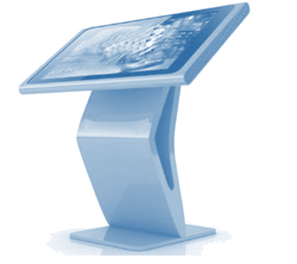

**Answers**

|  |  |  |  |  |
| --- | --- | --- | --- | --- |
|  | ***Term*** |  |  | ***Explanation*** |
| **1** | **Aesthetics** |  | **c** | The design of the whole kiosk enclosure. |
| **2** | **Interface** |  | **g** | The bits that the user interacts with. |
| **3** | **Graphics** |  | **a** | The visual elements, such as backgrounds and buttons. |
| **4** | **Components** |  | **f** | The computer, touchscreen, printer and other devices. |
| **5** | **Software** |  | **i** | The programs that control the data and interaction. |
| **6** | **Ergonomics** |  | **b** | Is the kiosk comfortable and easy to use? |
| **7** | **Manufacturing Volume** |  | **h** | The number of kiosks of this type that will be built. |
| **8** | **Maintenance** |  | **d** | Fixing any problems that occur with the kiosk. |
| **9** | **Compliance** |  | **j** | Making sure that everything is legal and appropriate. |
| **10** | **Durability** |  | **e** | Is the kiosk outside? How long will it survive? |

#### Task 4 – Sustainable Technology

1. Think about one location (e.g. a warehouse, restaurant, shop, outside a visitor centre in a national park etc.) and list the materials that might be needed in the manufacture of a kiosk. Consider the enclosure, the screen, inside the computer and so on. Also, say where each material might be used (e.g. plastic enclosure).

**Examples: plastic/steel/fibreglass enclosure;**

**glass/plastic/metal display;**

**copper/steel wires;   
steel/plastic/aluminium components;**

**gold/silver/palladium circuit boards etc.**

1. Mention some design features that could lengthen the lifespan of the kiosk you have thought about. For example, using steel for the enclosure of a kiosk in a warehouse could protect it from being damaged by stray trolleys and reversing forklift trucks. Consider the software as well as the physical parts.

**Depends on kiosk. Examples: strong enclosure; protection for touchscreen; updatable software; allow access to all components for replacement etc.**

|  |
| --- |
| **Interactive Kiosk Research Answers (page 2)** |

1. After several years of use, how might a kiosk be ‘refreshed’ or updated rather than scrapped?

**Update software; recreate kiosk interface; replace components; patch up fibreglass enclosures; repaint/respray surfaces; replace screen if scratched etc.**

1. Find out about some of the problems caused by throwing waste materials into landfill.

**Unsightly.   
Release of toxins (mercury, arsenic, cadmium, PVC, solvents, acids and lead) into the soil.  
Chemicals leach into water.  
Release of greenhouse gases (methane / carbon dioxide) into the atmosphere etc.**

1. Write about some of the issues with recycling the materials used to make electronic devices. What happens to the hazardous waste? Which countries deal with this?

**Very little is recycled; much ends up in landfill leaching hazardous toxins into the soil and waterways.   
Now frequently shipped (often illegally) to the Far East, India, Africa and China.**

1. Discuss how some of the materials might be recycled once the useful lifetime of a kiosk is over.

**Plastics can be recycled as plastic pellets then used in plastic furniture etc.  
Metals can be melted down and reused.  
Mercury might end up in dental amalgams, glass in insulation, phosphorus in fertilisers.**

1. Are there any parts of the kiosk that cannot be recycled or put to good use after the kiosk’s lifetime?

**Fibreglass is rarely recycled. Most materials can be recycled if care is taken.**